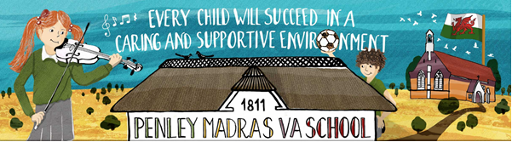

Minutes of Meeting
Date: January 2024 Present: JR, AC, LA, RS, AB, EW, JR, AB, AH, GB, RM, BK, HW, LH, MC, TR, LM

Focus | Discussion Points | Outcomes
Welcome and revision of school targets this year (SDP) | All were familiar with Welsh and Outdoor Learning – Outdoor Learning was happening in classes. Examples are dragon nest building, winter walks, making castles, cycling and forest school. KS2 classes have a sheet with hours spent outside that you colour in. | No action needed
Minutes from last meeting | Minutes looked over and approved. | No action needed
Feelings on school this term | LA asked for thoughts/feelings this new term. Any issues needed addressing.  Fresh start for everybody – started again well with our teacher back.  Y6 enjoyed road safety – really useful skills learned. Thoroughly recommend it to Y5  All enjoying new topic - Wonderful Wales. Lots of discussion on dragons.  SC enjoyed talking in assembly about their roles and how they can help with the views of children. | SC members to contribute to Tuesday assembly every month.
Issues raised | - Review of drive on manners – Not enough names in the book. SC think this is because of members forgetting, not that Madras has no manners! SC decided on posters for reminders.  - Lunch: SC had a request for chicken nuggets or meatballs on the school menu. Most disliked: Mac n Cheese/Cottage Pie. Vegetarians asked for vegetarian gravy.SC to ask their class – what is the least favourite lunch choice? SC members to feedback to JR and LA. Cook to be invited to our next meeting.  - Request in C2 for services in the afternoon – GB to find out why.  - Corridor monitors to address the noise levels. Everyone carries on talking as soon as we come in. No running. Monitor positions decided:3 per play – rota needed  - SC looked at the proposal for new School logo.All agreed and liked it. | EW/RM/HW/AB volunteered to make posters.  AC to collate names and nominate prize.  SC members to continue to listen carefully throughout their school day and note down any good examples.  SC members to go back to their class and conduct a survey about meals available.  LA/AB to do a rota
Fundraising | SC to ask for ideas from class members | Fundraising meeting to be held on 31-01-24  Fundraising committee to draw up action plan.
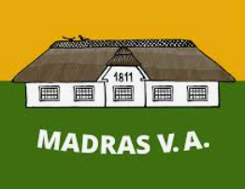
Minutes collated by: LM/JR

Article 12:
Children have the right to have their opinions
taken into account.

