Minutes of Meeting
Date: February 2024 Present: JR, AC, LA, AB, EW, JR, AB, AH, GB, RM, BK, HW, MC, TR, LM

Focus | Discussion Points | Outcomes
Welcome and revision of school targets this year (SDP) | All were familiar with Welsh and Outdoor Learning. | No action needed
Minutes from last meeting | Minutes looked over and approved.  Asked about the fundraiser – we raised £100. AJ invited to next meeting to say how she has spent £50 donation from SC | JR to invite AJ via e mail
Feelings on school this term | LA asked for thoughts/feelings this new term. Any issues needed addressing.  Likes this term are Rugby Tournament/BSL lesson.  Some are hoping for another football tournament.  We are excited for BeatBall and the Eisteddfodd | No action needed
Issues raised | - New school logo shared. Likes: date and birds. Suggestions: flowers on the grass/ children’s faces on the windows/ children holding hands around the circumference/ birds need to be smaller and more to the left.  - Lunchtime survey feedback: 93 voted for nuggets/ 12 against. Least favourite meals are Chicken Burrito/Mac n Cheese (too cheesy) and cottage pie. Another request was for vegetarian gravy.  - C3 Feedback: can we have crisps at break? Can we have an afternoon play? Can we have a box of activities in the hall for wet plays – classes on a rota?  - Corridor noise is unacceptable – Rota is needed. SC members to be put on a rota (2 per day)  - Manners book counted – heroes to be given out in service to children with most names in book. | Present comments/suggestions to HT  Present ideas to HT  Present deas to HT  AC and AB to devise a rota
Fundraising | Ideas discussed: Easter Colouring competition/ Egg head quiz/ | Fundraising Committee to meet up to discuss further.
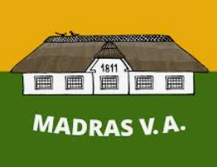
Minutes collated by: LM/JR

Article 12:
Children have the right to have their opinions
taken into account.

